Summer Training
Undertaken at
Defence Laboratory, Jodhpur
Defence Research and Development Organisation


Project Report on
“Software Development for Factorial, Gamma and Beta Functions Computation”
From: 27 May 2019
To: 12 July 2019

Guided by: Submitted by:
Sh. D.K. Tripathi Gaurav soni
Scientist ‘F’ B.Tech. (CSE)
Defence Laboratory, Jodhpur Govt. Engineering College
DRDO Bikaner

Certificate

This is to certify that Mr. Gaurav soni, student of B.Tech (CSE) from Government Engineering College, Bikaner has undergone practical summer training on project entitled “Software Development for Factorial, Gamma and Beta Functions Computation”at Defence Laboratory, Jodhpur during 27th May, 2019 to 15 July, 2019 under my guidance.
He worked diligently and made valuable contributions during this period. All his work is genuine and original.

(D.K. Tripathi)
Scientist 'F'
Defence Laboratory, Jodhpur
Defence Research and Development Organisation
Jodhpur - 342011

Acknowledgement

I take the opportunity to express my heartfelt gratitude to all those people who have provided their immense support and aspect their valuable time in guiding me. It is due to their support, guidance, encouragement and supervision that I have successfully completed practical training project on “Software Development for Factorial, Gamma and Beta Functions Computation”.
I am highly indebted to my guide Sh. D.K. Tripathi, Scientist 'F' for his guidance and constant supervision as well as for providing necessary information regarding the project.
I would like to articulate my gratitude towards Sh. Ravindra Kumar, OS & Director, Defence Laboratory, Jodhpur for giving me opportunity to apply theoretical knowledge into practice.
In the end, I would like to extend my sincere thanks to my friends and family members for their support, innovation ideas and positive criticisms.

(Gaurav Soni)
B.Tech. (Computer Science and Engineering)
Government Engineering College, Bikaner

Table of Contents

1. Introduction----------------------------------------------------------------------- 1
1.1 Numerical Analysis----------------------------------------------------- 1
1.2 Applications-------------------------------------------------------------- 1
2. Factorial, Gamma, Beta and Error Functions---------------------------- 3
2.1 Numerical Methods--------------------------------------------------- 3
2.2 Gamma Function------------------------------------------------------- 4
2.3 Beta Function----------------------------------------------------------- 5

2.4 Factorial Function----------------------------------------------------- 5
2.5 Error Function---------------------------------------------------------- 6
3. Software Design and Development--------------------------------------- 8
3.1 Hardware Requirement--------------------------------------------- 9
3.2 Software Requirement---------------------------------------------- 9
3.3 Software Development Life cycle-------------------------------- 9
4. Testing---------------------------------------------------------------------------- 12
4.1 Testing Methods----------------------------------------------------- 12
4.2 Some code testing’s------------------------------------------------ 15
5. Source Code Listings---------------------------------------------------------- 20
6. Conclusion----------------------------------------------------------------------- 31
References---------------------------------------------------------------------- 33

Chapter- 1

Introduction

1.1 Numerical analysis-
Numerical analysis, area of mathematics and computer science that creates, analyses, and implements algorithms for obtaining numerical solutions to problems involving continuous variables. Such problems arise throughout the natural sciences, social sciences, engineering, medicine, and business. Since the mid-20th century, the growth in power and availability of digital computers has led to an increasing use of realistic mathematical models in science and engineering, and numerical analysis of increasing sophistication is needed to solve these more detailed models of the world. The formal academic area of numerical analysis ranges from quite theoretical mathematical studies to computer science issues.
With the increasing availability of computers, the new discipline of scientific computing, or computational science, emerged during the 1980s and 1990s. The discipline combines numerical analysis, symbolic mathematical computations, computer graphics, and other areas of computer science to make it easier to set up, solve, and interpret complicated mathematical models of the real world.

1.2 Applications-

- Computer-aided engineering (CAE) is an important subject within engineering, and some quite sophisticated PSEs have been developed for this field. A wide variety of numerical analysis techniques is involved in solving such mathematical models. The models follow the basic Newtonian laws of mechanics, but there is a variety of possible specific models, and research continues on their design. One important CAE topic is that of modelling the dynamics of moving mechanical systems, a technique that involves both ordinary differential equations and algebraic equations (generally nonlinear). The numerical analysis of these mixed systems, called differential-algebraic systems, is quite difficult but necessary in order to model moving mechanical systems. Building simulators for cars, planes, and other vehicles requires solving differential-algebraic systems in real time.

- Atmospheric modelling: In addition to improving weather forecasts, such models are crucial for understanding the possible effects of human activities on the Earth’s climate. In order to create a useful model, many variables must be introduced. Fundamental among these are the velocity V(x, y, z, t), pressure P(x, y, z, t), and temperature T(x, y, z, t), all given at position (x, y, z) and time t. In addition, various chemicals exist in the atmosphere, including ozone, certain chemical pollutants, carbon dioxide, and other gases and particulates, and their interactions have to be considered. The underlying equations for studying V(x, y, z, t), P(x, y, z, t), and T(x, y, z, t) are partial differential equations; and the interactions of the various chemicals are described using some quite difficult ordinary differential equations. Many types of numerical analysis procedures are used in atmospheric modelling, including computational fluid mechanics and the numerical solution of differential equations. Researchers strive to include ever-finer detail in atmospheric models, primarily by incorporating data over smaller and smaller local regions in the atmosphere and implementing their models on parallel supercomputers.

- Software to implement common numerical analysis procedures must be reliable, accurate, and efficient. Moreover, it must be written to be easily portable between different computer systems. Since about 1970, a number of government-sponsored research efforts have produced specialized, high-quality numerical analysis software.

Chapter- 2

Factorial, Gamma, Beta and Error Functions

2.1 Numerical Methods for Integration

What is integration?
Integration is the process of measuring the area under a function plotted on a graph. Why would we want to integrate a function? Among the most common examples are finding the velocity of a body from an acceleration function, and displacement of a body from a velocity function. Throughout many engineering fields, there are (what sometimes seems like) countless applications for integral calculus.
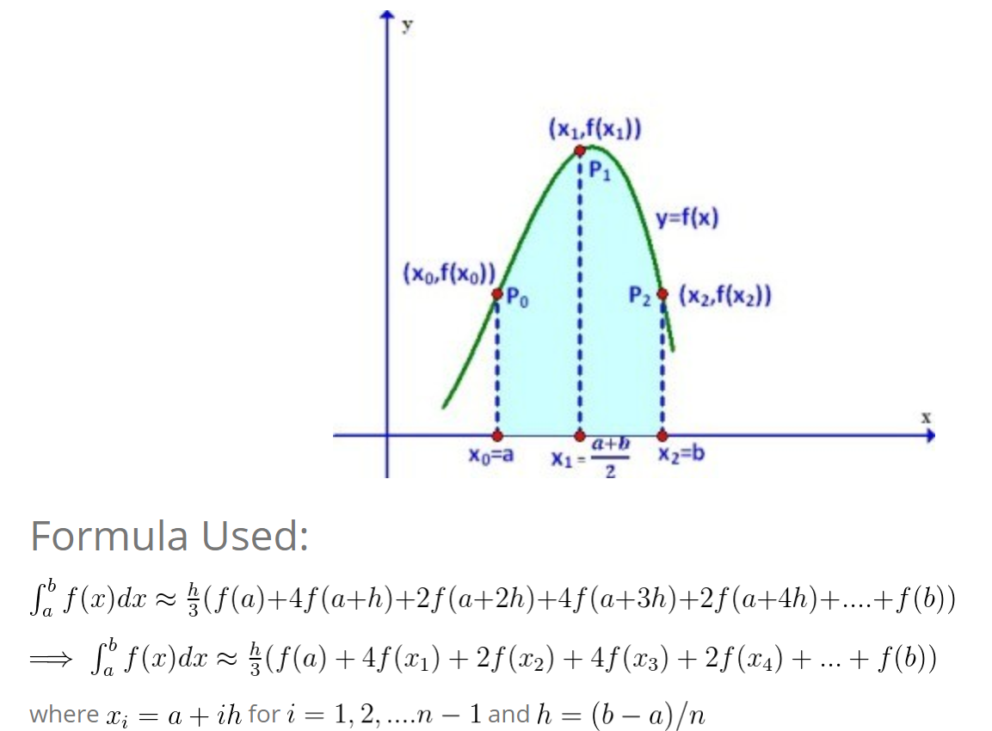
Simpson’s 1/3 rule is an extension of Trapezoidal rule where the integrand is approximated by a second order polynomial.
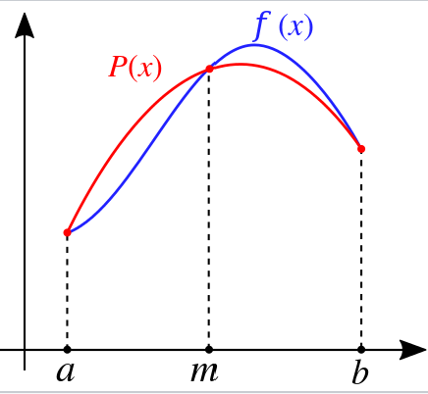

2.2 Gamma Function
The (complete) gamma function is defined to be an extension of the factorial to complex and real number arguments. It is related to the factorial by
a slightly unfortunate notation due to Legendre which is now universally used instead of Gauss's simpler .
It is analytic everywhere except at , , , ..., and the residue at is
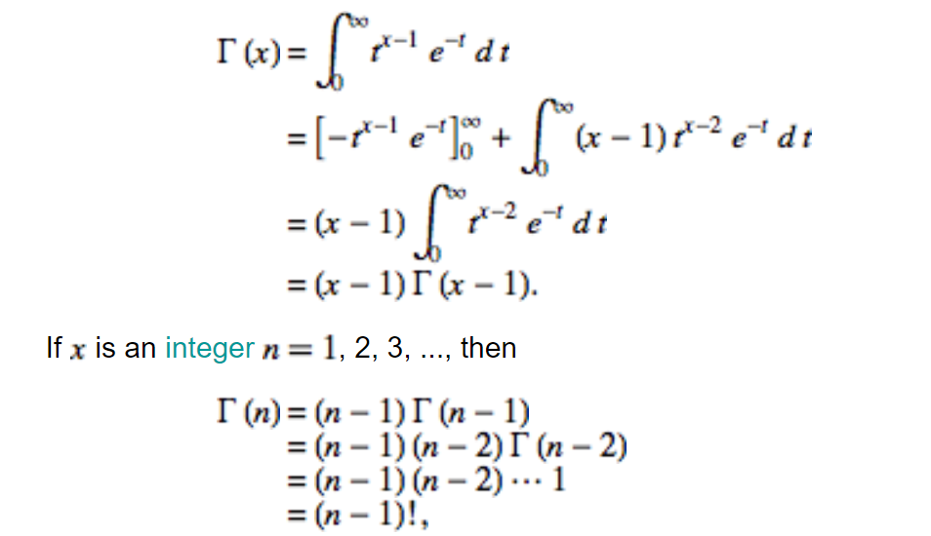
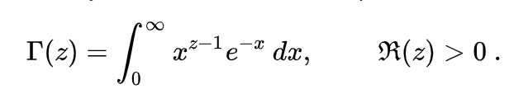

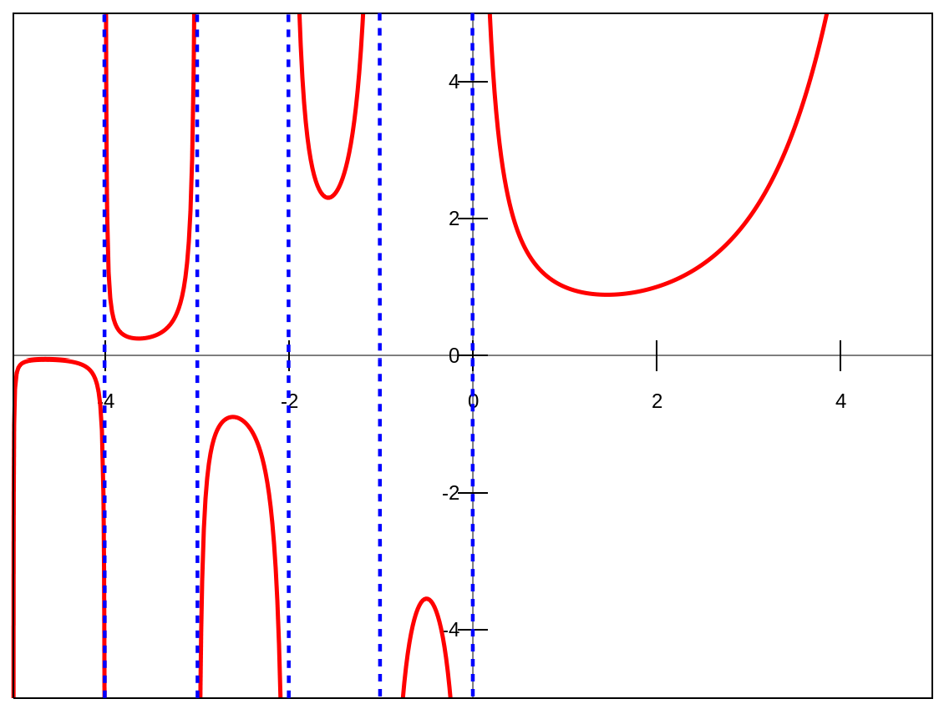

2.3 Beta Function
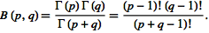
The beta function is the name used by Legendre, Whittaker, and Watson (1990) for the beta integral (also called the Eulerian integral of the first kind). It is defined by

The beta function is implemented in the Wolfram Language as Beta[a, b].
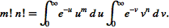
To derive the integral representation of the beta function, write the product of two factorials as

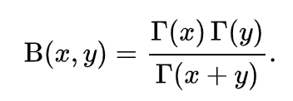
A key property of the beta function is its relationship to the gamma function; proof is given below in the section on relationship between gamma function and beta function

2.4 Factorial Function
The factorial is defined for a positive integer as
So, for example, . An older notation for the factorial was written The special case is defined to have value , consistent with the combinatorial interpretation of there being exactly one way to arrange zero objects (i.e., there is a single permutation of zero elements, namely the empty set ).
The triangular number can be regarded as the additive analogy of the factorial. Another relationship between factorials and triangular numbers is given by the identity
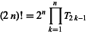
Stirling's approximation (or Stirling's formula) is an approximation for factorials. It is a good approximation, leading to accurate results even for small values of n. It is named after James Stirling, though it was first stated by Abraham de Moivre.
The version of the formula typically used in applications is
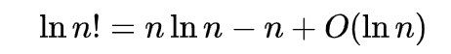
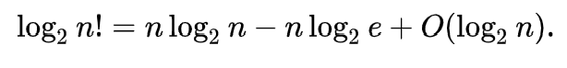
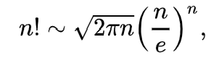
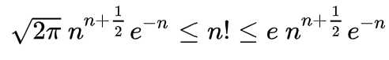

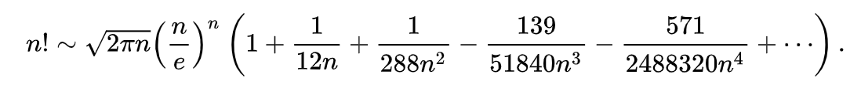
Euler’s Correction is a correction to the Stirling’s Approximation,

2.5 Error Function
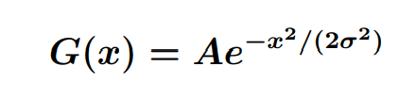
The error function and the complementary error function are important special functions, which appear in the solutions of diffusion problems in heat, mass and momentum transfer, probability theory, the theory of errors and various branches of mathematical physics. It is interesting to note that there is a direct connection between the error function and the Gaussian function and the normalized Gaussian function that we know as the “bell curve”. The Gaussian function is given as

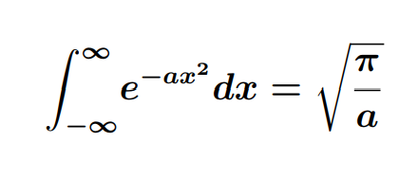
Where σ is the standard deviation and A is a constant. The Gaussian function can be normalized so that the accumulated area under the curve is unity, i.e. the integral from −∞ to +∞ equals 1. If we note that the definite integral

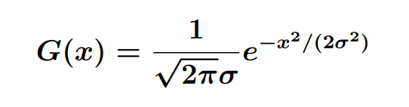
Then the normalized Gaussian function takes the form

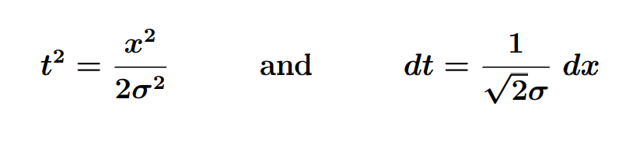

Then the normalized Gaussian integrated between −x and +x can be written as
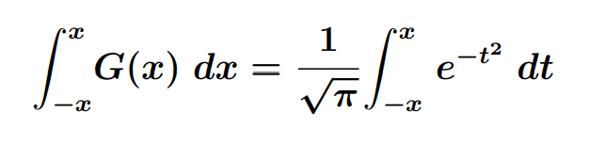

Or recognizing that the normalized Gaussian is symmetric about the y−axis, we can write
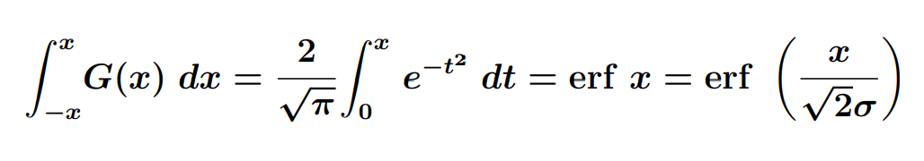
And the complementary error function can be written as,
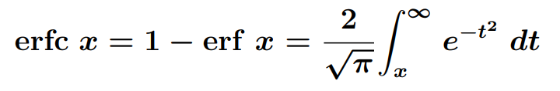

Error function can be written as,

Chapter- 3

Software Design and Development

Software is instruction (computer program) that when executed provide desired feature, and performance. Software engineering encompasses process, methods, and tools that enable complex computer-based systems to be built in a timely manner with quality. The software process incorporates five framework activities- communication, planning, modelling, construction, and deployment- that are applicable to all software engineering practise is a problem solving activity that follows a set of core principles.
Design concepts have evolved over the first 60 years of software engineering work. They describe attributes of computer software that should be present regardless of the software engineering process that is chosen, the design methods that are applied, or the programming languages that are used. In essence, design concept emphasize the need for abstraction as a mechanism for creating reusable software components; the important of architecture as a way to better understand the overall structure of the system; the benefits of the pattern based engineering as a technique for designing software with proven capabilities; the value of separation of concerns and effective modularity as a way to make software more understandable, more testable, and more maintainable; the consequence of information hiding as a mechanism for reducing the propagation of side effects when errors do occur; the impact of functional independence as a criterion for building effective modules; the use of refinement as a design mechanism; a consideration of aspects that crosscut system requirement; the application of refactoring for optimizing the design that is derived; and the importance of object-oriented classes and the characteristics that are related to them.

3.1 Hardware Requirement:
Processor: Any Processor (Intel or AMD)
Installed Memory: More than 2:00 GB
System type: 32 or 64-bit Operating System

3.2 Software Requirement:
Operating System: Any operating system (Windows, Linux, Mac, etc.)
Compiler: C++ compiler.

3.3 Software Development Life Cycle:
The Waterfall Model was first Process Model to be introduced. It is also referred to as a linear-sequential life cycle model. It is very simple to understand and use. In a waterfall model, each phase must be completed before the next phase can begin and there is no overlapping in the phases.
Waterfall model is the earliest SDLC approach that was used for software development.
The waterfall Model illustrates the software development process in a linear sequential flow; hence, it is also referred to as a linear-sequential life cycle model. This means that any phase in the development process begins only if the previous phase is complete. In waterfall model phases do not overlap.

Waterfall Model design:
Waterfall approach was first SDLC Model to be used widely in Software Engineering to ensure success of the project. In "The Waterfall" approach, the whole process of software development is divided into separate phases. In Waterfall model, typically, the outcome of one phase acts as the input for the next phase sequentially.
Following is a diagrammatic representation of different phases of waterfall model.
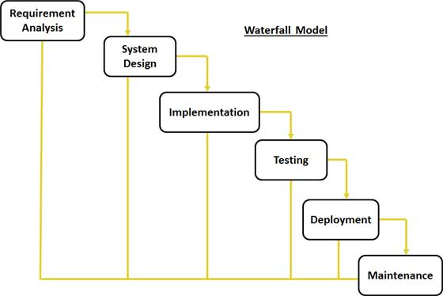
The sequential phases in Waterfall model are:

- Requirement Gathering and analysis: All possible requirements of the system to be developed are captured in this phase and documented in a requirement specification doc
- System Design: The requirement specifications from first phase are studied in this phase and system design is prepared. System Design helps in specifying hardware and system requirements and also helps in defining overall system architecture.
- Implementation: With inputs from system design, the system is first developed in small programs called units, which are integrated in the next phase. Each unit is developed and tested for its functionality which is referred to as Unit Testing.
- Integration and Testing: All the units developed in the implementation phase are integrated into a system after testing of each unit. Post integration the entire system is tested for any faults and failures.
- Deployment of system: Once the functional and non functional testing is done, the product is deployed in the customer environment or released into the market.
- Maintenance: There are some issues which come up in the client environment. To fix those issues patches are released. Also to enhance the product some better versions are released. Maintenance is done to deliver these changes in the customer environment.
All these phases are cascaded to each other in which progress is seen as flowing steadily downwards (like a waterfall) through the phases. The next phase is started only after the defined set of goals are achieved for previous phase and it is signed off, so the name "Waterfall Model". In this model phases do not overlap.

Waterfall Model Application
Every software developed is different and requires a suitable SDLC approach to be followed based on the internal and external factors. Some situations where the use of Waterfall model is most appropriate are:
- Requirements are very well documented, clear and fixed.
- Product definition is stable.
- Technology is understood and is not dynamic.
- There are no ambiguous requirements.
Ample resources with required expertise are available to support the product.
The project is short.

Chapter- 4

Testing

Software testing is an investigation conducted to provide stakeholders with information about the quality of the product or service under test. Software testing can also provide an objective, independent view of the software to allow the business to appreciate and understand the risks of software implementation. Test techniques include, but are not limited to the process of executing a program or application with the intent of finding software bugs (errors or other defects).
Software testing can be stated as the process of validating and verifying that a computer program/application/product:
- Works as expected,
- Can be implemented with the same characteristics,
- Satisfies the needs of stakeholders.
Software testing, depending on the testing method employed, can be implemented at any time in the software development process. Traditionally most of the test effort occurs after the requirements have been defined and the coding process has been completed, but in the agile approaches most of the test effort is on going.

4.1 Testing Methods:

Static vs. dynamic testing:

Static testing involves verification, whereas dynamic testing involves validation. Together they help improve software quality. Among the techniques for static analysis, mutation testing can be used to ensure the test cases will detect errors, which are introduced by mutating the source code.

The box approach:
Software testing methods are traditionally divided into white- and black-box testing. These two approaches are used to describe the point of view that a test engineer takes when designing test cases.

White-Box testing:
White-box testing (also known as clear box testing, glass box testing, and transparent box testing and structural testing) tests internal structures or workings of a program, as opposed to the functionality exposed to the end-user. In white-box testing an internal perspective of the system, as well as programming skills, are used to design test cases. The tester chooses inputs to exercise paths through the code and determine the appropriate outputs. This is analogous to testing nodes in a circuit, e.g. in-circuit testing (ICT).
While white-box testing can be applied at the unit, integration and system levels of the software testing process, it is usually done at the unit level. It can test paths within a unit, paths between units during integration, and between subsystems during a system–level test. Though this method of test design can uncover many errors or problems, it might not detect unimplemented parts of the specification or missing requirements.
- Techniques used in white-box testing include:
- API testing (application programming interface) – testing of the application using public and private APIs
- Code coverage – creating tests to satisfy some criteria of code coverage (e.g., the test designer can create tests to cause all statements in the program to be executed at least once)
- Fault injection methods – intentionally introducing faults to gauge the efficacy of testing strategies
- Mutation testing methods
- Static testing methods
Code coverage tools can evaluate the completeness of a test suite that was created with any method, including black-box testing. This allows the software team to examine parts of a system that are rarely tested and ensures that the most important function points have been tested. Code coverage as a software metric can be reported as a percentage for:
- Function coverage, which reports on functions executed
- Statement coverage, which reports on the number of lines executed to complete the test
100% statement coverage ensures that all code paths or branches (in terms of control flow) are executed at least once. This is helpful in ensuring correct functionality, but not sufficient since the same code may process different inputs correctly or incorrectly.

Black-box testing:
Black-box testing treats the software as a "black box", examining functionality without any knowledge of internal implementation. The testers are only aware of what the software is supposed to do, not how it does it. Black-box testing methods include: equivalence partitioning boundary value analysis, all-pairs testing, state transition tables, decision table testing, fuzz testing, model-based testing, use case testing, exploratory testing and specification-based testing.
- Specification-based testing:
It aims to test the functionality of software according to the applicable requirements. This level of testing usually requires thorough test cases to be provided to the tester, who then can simply verify that for a given input, the output value (or behaviour),”is" or "is not" the same as the expected value specified in the test case. Test cases are built around specifications and requirements, i.e., what the application is supposed to do. It uses external descriptions of the software, including
Specifications, requirements, and designs to derive test cases. These tests can be functional or non-functional, though usually functional.
Specification-based testing may be necessary to assure correct functionality, but it is insufficient to guard against complex or high-risk situations.
One advantage of the black box technique is that no programming knowledge is required. Whatever biases the programmers may have had, the tester likely has a different set and may emphasize different areas of functionality. On the other hand, black-box testing has been said to be "like a walk in a dark labyrinth without a flashlight. Because they do not examine the source code, there are situations when a tester writes many test cases to check something that could have been tested by only one test case, or leaves some parts of the program untested.
This method of test can be applied to all levels of software testing: unit, integration, system and acceptance. It typically comprises most if not all testing at higher levels, but can also dominate unit testing as well.

Functional and non-functional testing:
Functional testing refers to activities that verify a specific action or function of the code. These are usually found in the code requirements documentation, although some development methodologies work from use cases or user stories. Functional tests tend to answer the question of "can the user do this" or "does this particular feature work."
Non-functional testing refers to aspects of the software that may not be related to a specific function or user action, such as scalability or other performance, behaviour under certain constraints, or security. Testing will determine the breaking point, the point at which extremes of scalability or performance leads to unstable execution. Non-functional requirements tend to be those that reflect the quality of the product, particularly in the context of the suitability perspective of its users.

4.2 Code testing’s:
Gamma calculation at various sub-intervals, and its effect on accuracy.

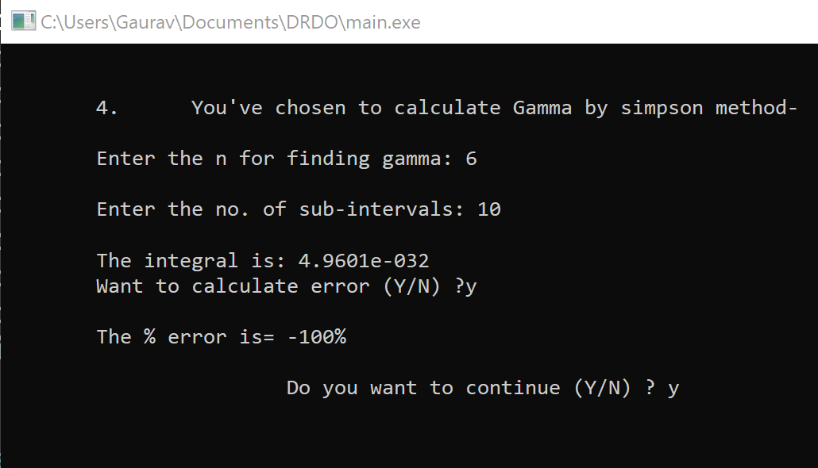
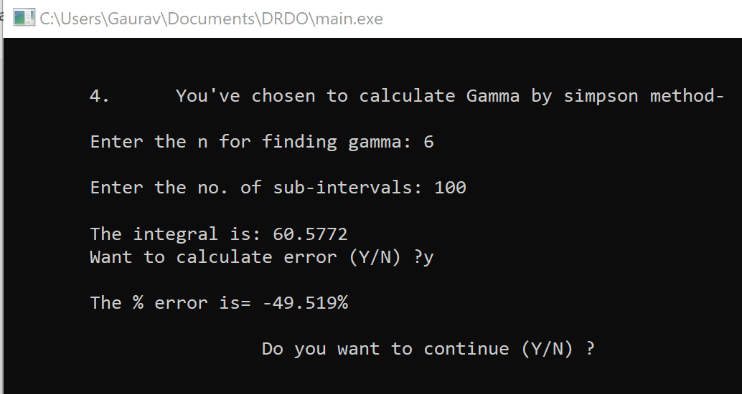

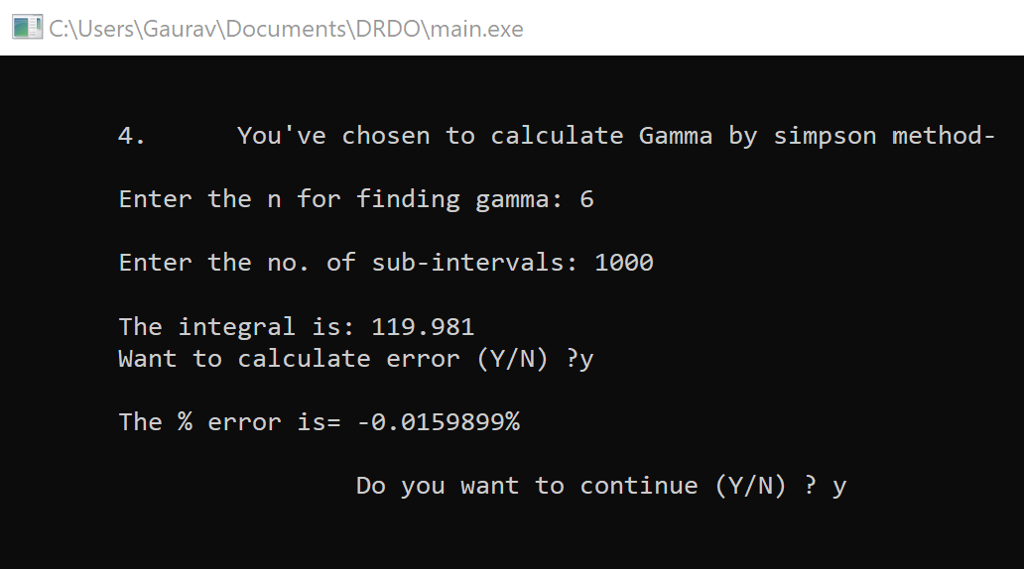
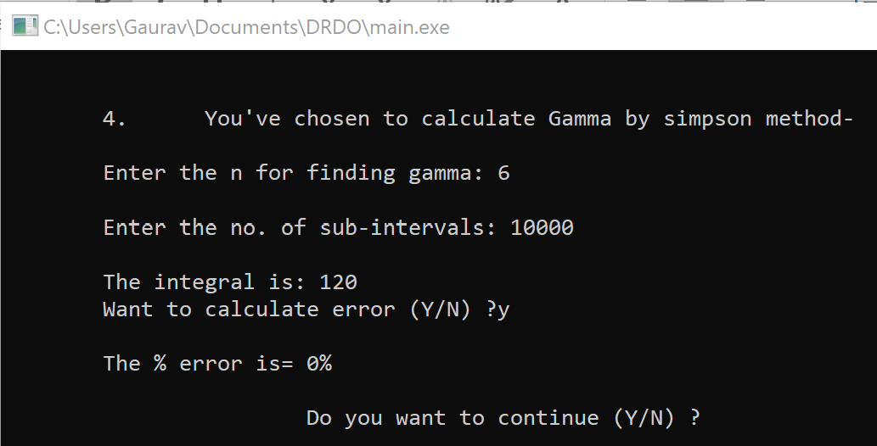

Sub-Intervals | Value | Error %
10 | 4.961*10^-32 | >100
100 | 60.5772 | 49.519
1000 | 119.981 | 0.0159899
10000 | 120 | 0
*All the values are calculated in double datatype

As the interval size is increased, there is drastic improvement in accuracy, 0% error is valid for double datatype only, as there will be a bigger datatype used there will be a small chance of error. In such case, the Sub-Intervals should be further increased.

Another such example is Beta calculation,
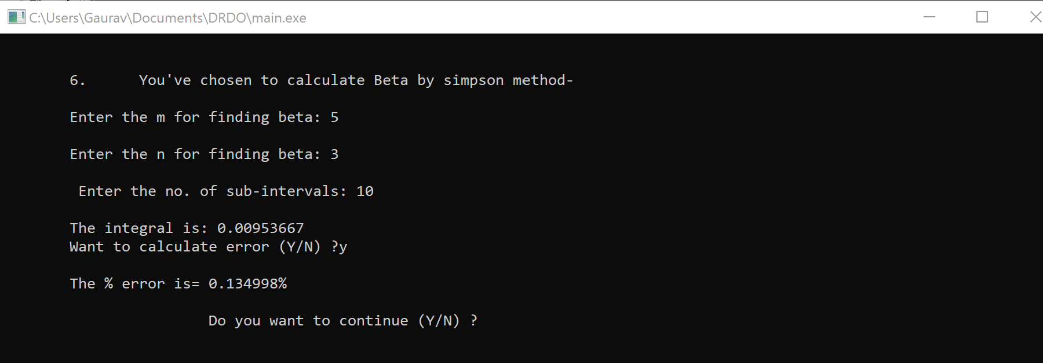

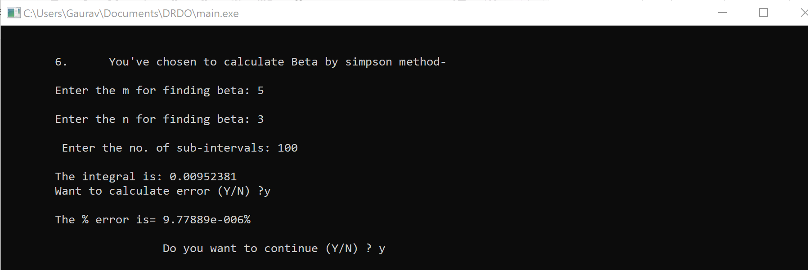

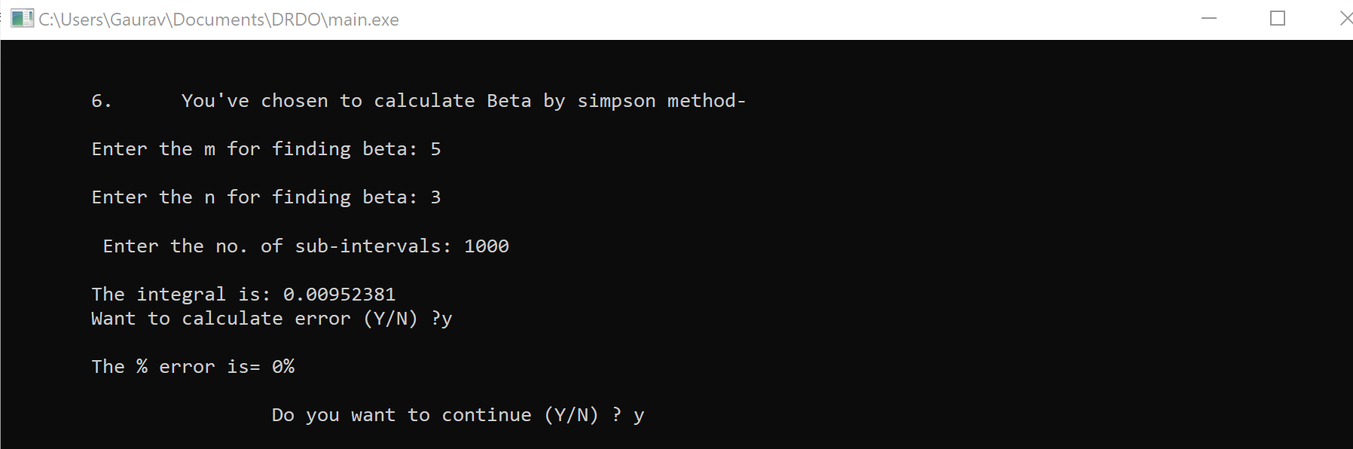

Sub-Intervals | Value | Error %
10 | .00953667 | .134998
100 | .00952381 | 9.7789*10^-6
1000 | .00952381 | 0
10000 | .00952381 | 0
*All the values are calculated in double datatype

The error percentage decreases with the increase in sub-intervals, higher the number of intervals the more precise and accurate will be the beta. Here the limitation of datatype plays a major role where the answer is accurate to the eighth decimal place but error is still encountered, in such case, the higher bit datatype is to be used to remove such error.

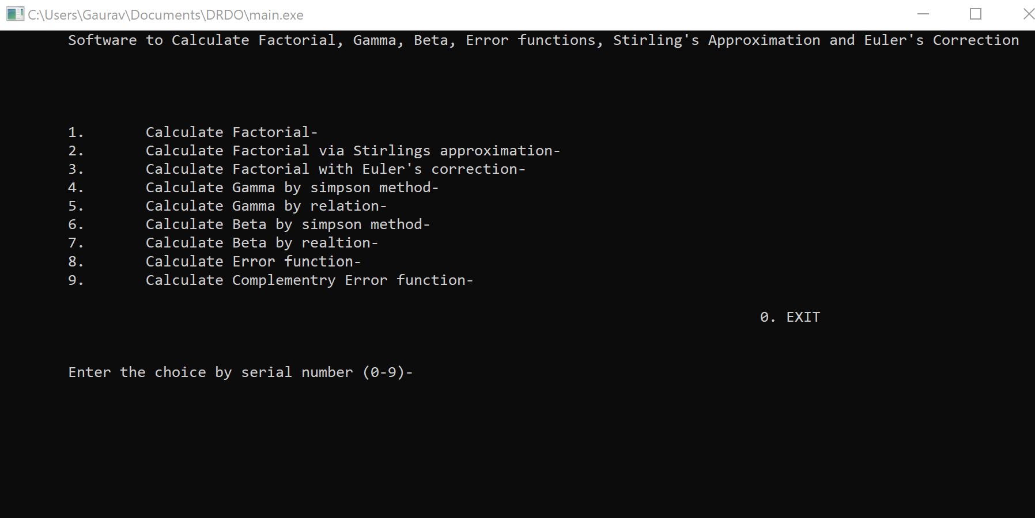
Menu
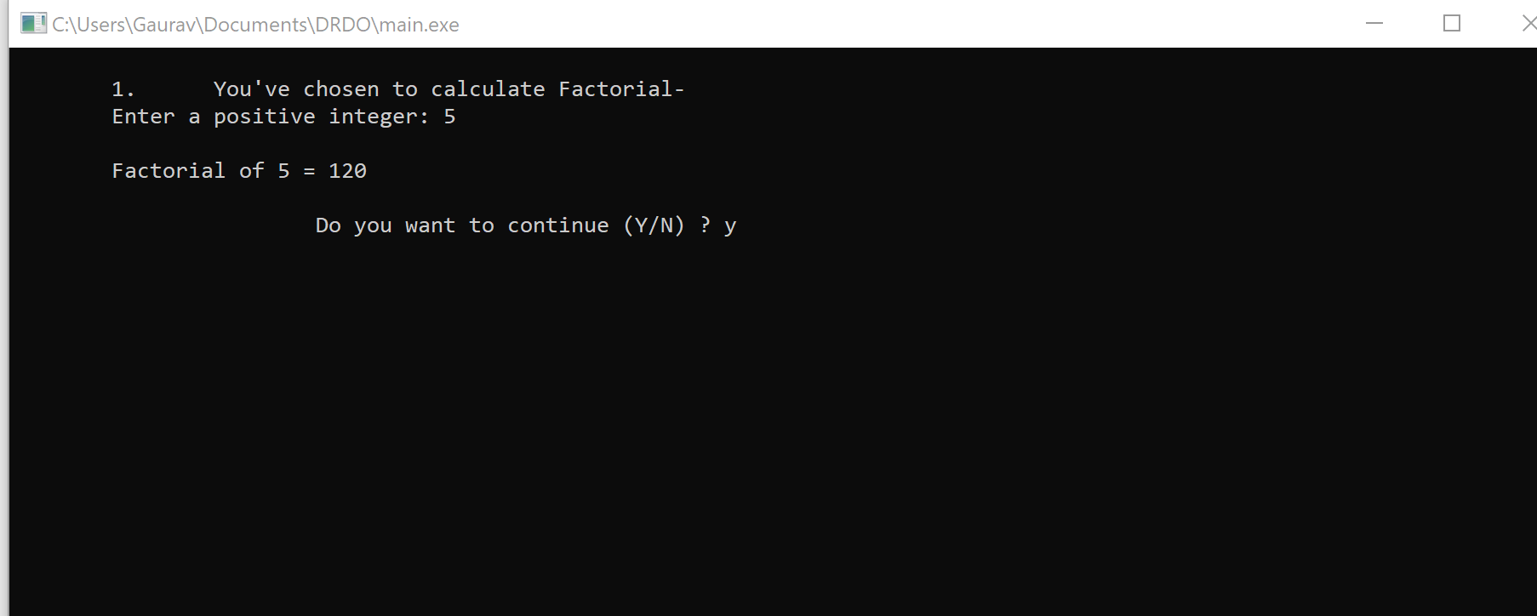

Factorial
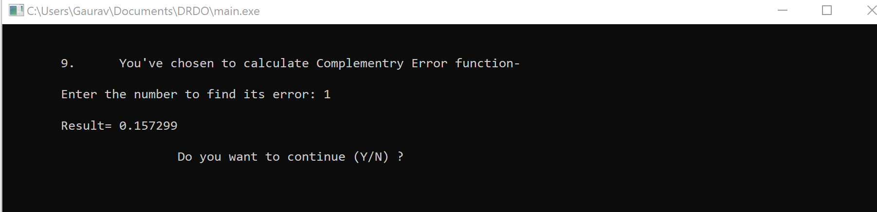

Complementry Error Function
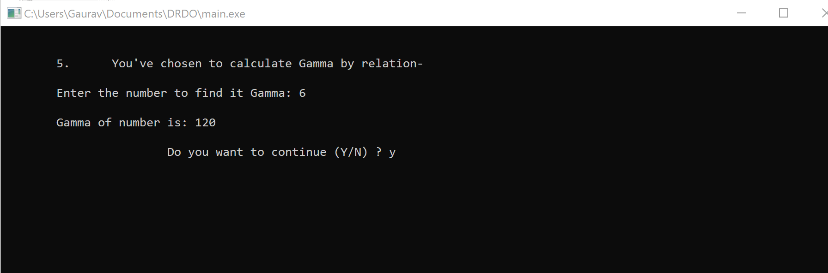
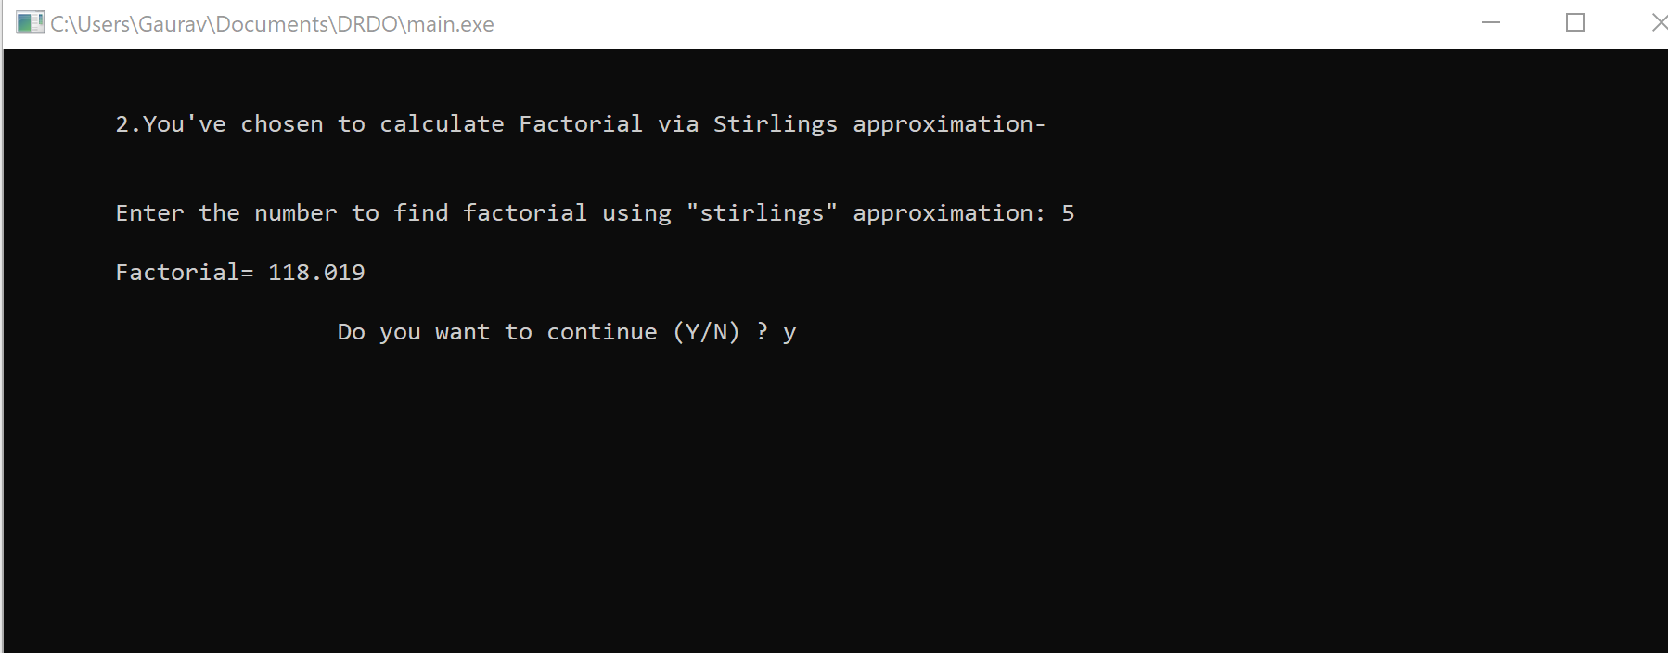Factorial by Stirling’s Approximation

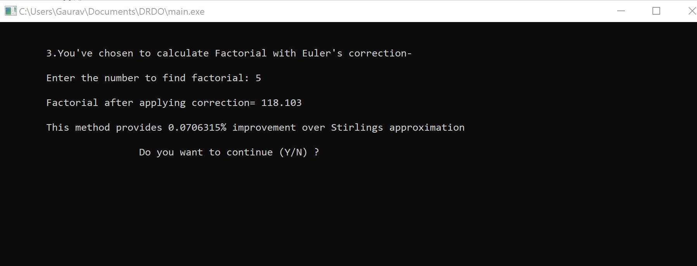
Factorial after Euler’s Correction

Gamma by factorial realtion

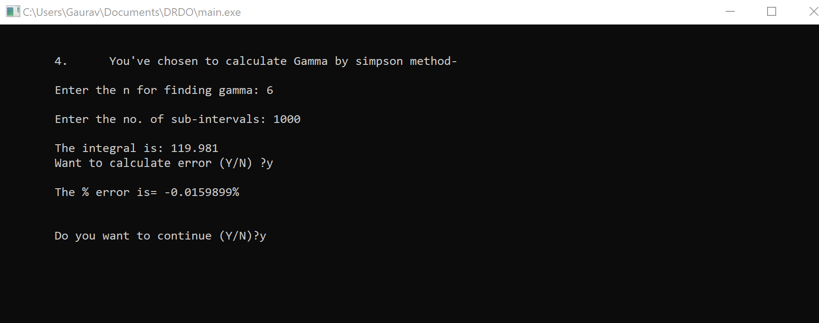

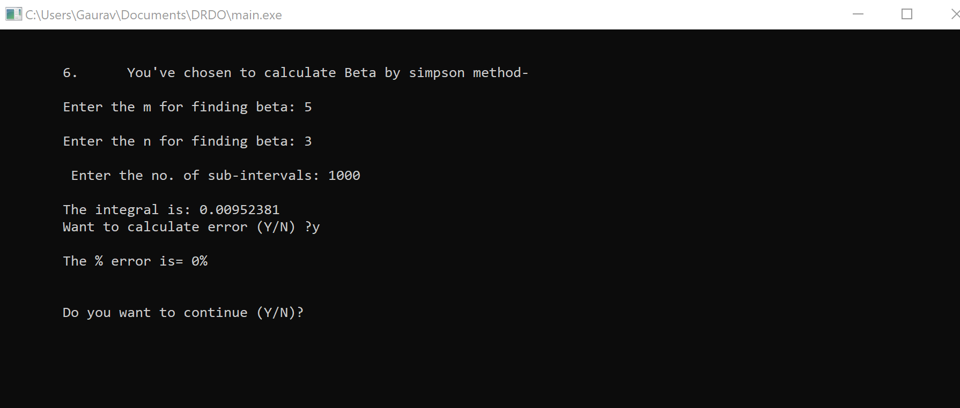
Gamma by Simpson method

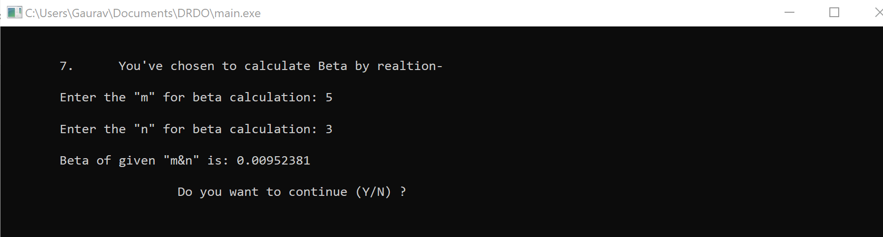
Beta by simpson method

Beta by relation
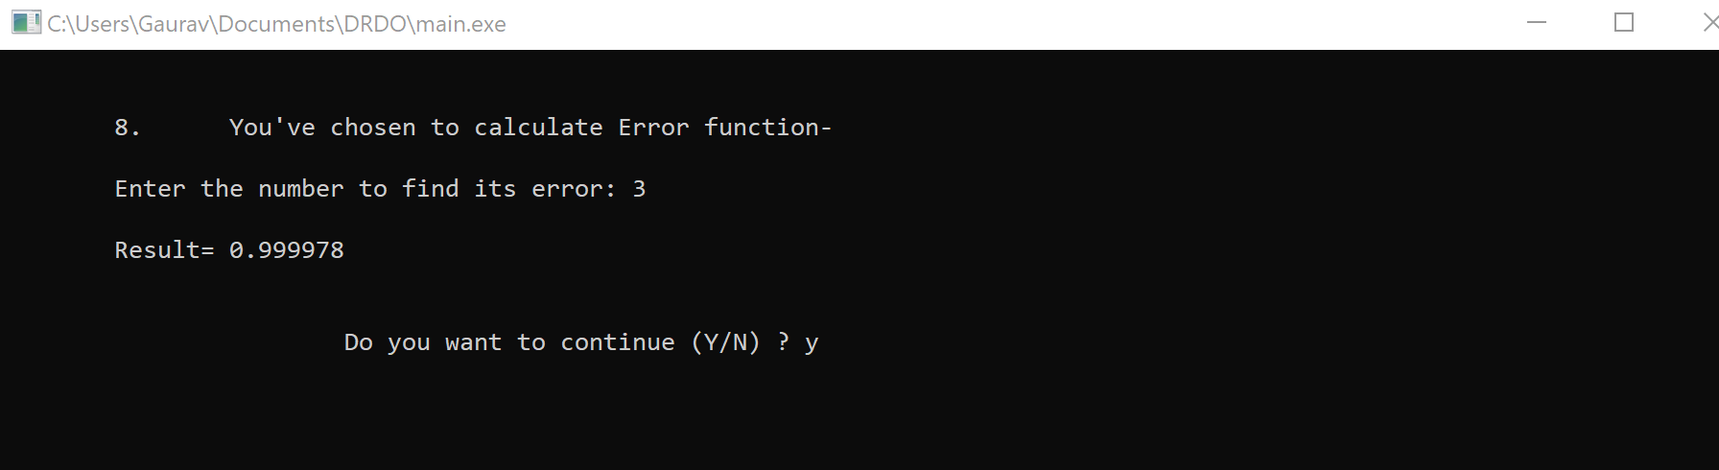

Error Function
Chapter- 5

Source Code Listings
#include<iostream>
#include<math.h>
#include<conio.h>
#include<stdlib.h>
#define e 2.718281828 //Constants
#define pi 3.141592653
char repeat,repeat_sub;
int choice,n,g,m,m_gamma,n_gamma;
float error;
double temp1,temp2;

using namespace std;

/*All the functions used in software*/

double f_beta(double x, int n_gamma, int m_gamma);
double f_gamma(double x,int n_gamma);
double beta (int n, int n_gamma,int m_gamma);
double gamma(int n, int n_gamma);
int gamma_rel(int gama);
float beta_rel(int m, int n);
float facit_strling(float n);
float euler_correct(float n);
float percenterror(float m, float n);
double erfc(int x);
double erf(int x);
int factorial(int n);
void menu (void);
double checkerror(void);

//Definations of functions

double f_beta(double x, int n_gamma, int m_gamma)
{
return pow(x,m_gamma-1)*pow(1-x,(n_gamma-1));
}

double f_gamma(double x,int n_gamma)
{
return pow(x,n_gamma-1)*pow(e,(-1*x));
}

double beta (int n, int n_gamma,int m_gamma)
{
unsigned int i;
int initial_limit=0,final_limit=1;
double b,h,x,sum=0,integral;
//Begin Simpson's Procedure:
h=fabs(final_limit-initial_limit)/n;
for(i=1;i<n;i++){
x=initial_limit+i*h;
if(i%2==0){
sum=sum+2*f_beta(x,n_gamma,m_gamma);
}
else{
sum=sum+4*f_beta(x,n_gamma,m_gamma);
}
}
integral=(h/3)*(f_beta(initial_limit,n_gamma,m_gamma)+f_beta(final_limit,n_gamma,m_gamma)+sum);
temp2=integral;
temp1=beta_rel(n_gamma,m_gamma);
//Print the answer
return integral;
}

double gamma(int n, int n_gamma)
{
unsigned int i;
int initial_limit=0,final_limit=1000;
double b,h,x,sum=0,integral;
//Begin Simpson's Procedure:
h=fabs(final_limit-initial_limit)/n;
for(i=1;i<n;i++){
x=initial_limit+i*h;
if(i%2==0){
sum=sum+2*f_gamma(x,n_gamma);
}
else{
sum=sum+4*f_gamma(x,n_gamma);
}
}
integral=(h/3)*(f_gamma(initial_limit,n_gamma)+f_gamma(final_limit,n_gamma)+sum);
//Print the answer
temp2=integral;
temp1=gamma_rel(n_gamma);
return integral;
}

float beta_rel (int m,int n)
{
int gm,gn,gmn;
float s;
gmn=m+n;
gm=gamma_rel(m);
gn=gamma_rel(n);
gmn=gamma_rel(gmn);
s=gm*gn;
s=s/gmn;
return s;
}

int gamma_rel(int gama)
{
int product=1,i;
for(i=1;i<=gama-1;i++)
{
product=product*i;
}
return product;
}

float fact_stirling(float n)
{
n=(sqrt(2*pi*n))*(pow(n,n))*(pow(e,(-1*n)));
return n;
}

float euler_correct(float n)
{
n=(sqrt(2*pi*n))*(pow(n,n))*(pow(e,(-1*n)));
n=n*(1+(1/(12*n))+(1/(288*n*n))-(139/(51840*n*n*n))-(571/(2488320*n*n*n*n)));
return n;
}

float percenterror(float obt, float abs)
{
float error;
if(obt>=abs)
error=((obt/abs)*100)-100;
else
error=-1*(100-((obt/abs)*100));
return error;
}

double erf(int x)
{
double a1 = 0.254829592; //Constants
double a2 = -0.284496736;
double a3 = 1.421413741;
double a4 = -1.453152027;
double a5 = 1.061405429;
double p = 0.3275911;

float sign = 1;
if (x < 0)
sign = -1;
x = abs(x);
double t = 1.0/(1.0 + p*x);
double y = 1.0 - (((((a5*t + a4)*t) + a3)*t + a2)*t + a1)*t*pow(e,(-1*x*x));

return sign*y;
}

double erfc(int x)
{
return 1-erf(x);
}

int factorial(int n)
{
if(n > 1)
return n * factorial(n - 1);
else
return 1;
}

void menu (void)
{
system("cls");
cout<<"\tSoftware to Calculate Factorial, Gamma, Beta, Error functions, Stirling's Approximation and Euler's Correction\n\n\n";
cout<<"\n\n\t1.\t Calculate Factorial-";
cout<<"\n\t2.\t Calculate Factorial via Stirlings approximation-";
cout<<"\n\t3.\t Calculate Factorial with Euler's correction- ";
cout<<"\n\t4.\t Calculate Gamma by simpson method- ";
cout<<"\n\t5.\t Calculate Gamma by relation- ";
cout<<"\n\t6.\t Calculate Beta by simpson method- ";
cout<<"\n\t7.\t Calculate Beta by realtion- ";
cout<<"\n\t8.\t Calculate Error function- ";
cout<<"\n\t9.\t Calculate Complementry Error function- ";
cout<<"\n\t\t\t\t\t\t\t\t\t\t\t\t\t\t\t\t\t\t\t\t\t\t\t\t\t\t\t0. EXIT\n";
cout<<"\n\n\tEnter the choice by serial number (0-9)- ";
cin>>choice;
}

double checkerror(void)
{
cout<<"\n\tWant to calculate error (Y/N) ?";
cin>>repeat_sub;
if(repeat_sub=='y'||repeat_sub=='Y')
cout<<"\n\tThe % error is= "<<percenterror(temp2, temp1)<<"%";
}
//Begining of main

int main()
{
do
{
menu();
switch(choice)
{
case(0):
{
exit(0);
}
case(1):
{
system("cls");
cout<<"\n\n\t1.\tYou've chosen to calculate Factorial- ";
cout<<"\n\n\tEnter a positive integer: ";
cin>>n;
cout<<"\n\tFactorial of " << n << " = " << factorial(n);
}break;
case(2):
{
system("cls");
cout<<"\n\n\t2.\tYou've chosen to calculate Factorial via Stirlings approximation- ";
cout<<"\n\n\tEnter the number to find factorial using \"stirlings\" approximation: ";
cin>>n;
cout<<"\n\tFactorial= "<<fact_stirling(n);
}break;
case(3):
{
system("cls");
cout<<"\n\n\t3.\tYou've chosen to calculate Factorial with Euler's correction- ";
cout<<"\n\n\tEnter the number to find factorial: ";
cin>>n;
cout<<"\n\tFactorial after applying correction= "<<euler_correct(n);
float temp_stir;
temp_stir=fact_stirling(n);
temp_stir=percenterror(euler_correct(n),temp_stir);
cout<<"\n\n\tThis method provides "<<temp_stir<<"% improvement over Stirlings approximation";
}break;
case(4):
{
system("cls");
cout<<"\n\n\t4.\tYou've chosen to calculate Gamma by simpson method- ";
cout<<"\n\n\tEnter the n for finding gamma: ";
cin>>n_gamma;
cout<<"\n\tEnter the no. of sub-intervals: ";
cin>>n;
cout<<"\n\tThe integral is: "<<gamma(n,n_gamma);
checkerror();
}break;
case(5):
{
system("cls");
cout<<"\n\n\t5.\tYou've chosen to calculate Gamma by relation- ";
cout<<"\n\n\tEnter the number to find its Gamma: ";
cin>>g;
cout<<"\n\tGamma of number is: "<<gamma_rel(g);
}break;
case(6):
{
system("cls");
cout<<"\n\n\t6.\tYou've chosen to calculate Beta by simpson method- ";
cout<<"\n\n\tEnter the m for finding beta: ";
cin>>m_gamma;
cout<<"\n\tEnter the n for finding beta: ";
cin>>n_gamma;
cout<<"\n\t Enter the no. of sub-intervals: ";
cin>>n;
cout<<"\n\tThe integral is: "<<beta(n,n_gamma,m_gamma);
checkerror();
}break;
case(7):
{
system("cls");
cout<<"\n\n\t7.\tYou've chosen to calculate Beta by realtion- ";
cout<<"\n\n\tEnter the \"m\" for beta calculation: ";
cin>>m;
cout<<"\n\tEnter the \"n\" for beta calculation: ";
cin>>n;
cout<<"\n\tBeta of given \"m&n\" is: "<<beta_rel(m,n);
}break;
case(8):
{
system("cls");
cout<<"\n\n\t8.\tYou've chosen to calculate Error function- ";
cout<<"\n\n\tEnter the number to find its error: ";
cin>>n;
cout<<"\n\tResult= "<<erf(n)<<endl;
}break;
case(9):
{
system("cls");
cout<<"\n\n\t9.\tYou've chosen to calculate Complementry Error function- ";
cout<<"\n\n\tEnter the number to find its error: ";
cin>>n;
cout<<"\n\tResult= "<<erfc(n);
}break;
}
cout<<"\n\n\t\t\tDo you want to continue (Y/N) ? ";
cin>>repeat;
}while(repeat=='Y'||repeat=='y');
return 0;
}

Chapter- 6

Conclusion
Numerical integration schemes should be applied to nonlinear systems with knowledge of the caveats involved. The absolute-stability boundaries may be very different from the linear case, so a linear stability analysis may well be misleading. A problem may occur if a reduction in step length happens to take one outside the absolute-stability region due to the shape of the boundary. In this case, the usual step-control schemes would have disastrous results on the problem, as step-length reduction in an attempt to increase accuracy would have the opposite effect.
Even inside the absolute-stability boundary, not all may be well due to the existence of stable ghost fixed points in many problems. Since basin boundaries are finite, starting too far from the real solution may land one in the basin of attraction of a ghost fixed point. Contrary to expectation, this incorrect behaviour is not prevented by insisting that the method be convergent.
Stiffness needs a new and better definition for nonlinear systems. We have provided a verbal description, but a mathematical definition is still lacking. There is a lot of scope to investigate further the interaction between stiffness and chaos. Explicit Runge--Kutta schemes should not be used for stiff problems, due to their inefficiency: Backward Differentiation Formulae methods, or possibly implicit Runge--Kutta methods, should be used instead.
Dynamics is not only interested in problems with fixed point solutions, but also in periodic and chaotic behaviour. This is something that has not in the past been fully appreciated by some workers in numerical analysis who have tended to concentrate on obtaining results, such as those of nonlinear stability theory, that require properties like contractility which are too restrictive for most dynamical systems.
There are results that tie the limit set of the Runge--Kutta map to that of the ordinary differential equation from which it came, but they are not as powerful as those which relate the dynamics of Poincare maps to their differential equations. Structurally stable behaviour in the ordinary differential equation is correctly portrayed in the Runge--Kutta map, but additional limit-set behaviour may be found in the map that is not present in the differential equation. No hyperbolic behaviour will probably not be correctly represented by the Runge--Kutta method.
Shadowing theory offers hope that it will be possible to produce numerical methods with built-in proofs of correctness of the orbits they produce, at least for hyperbolic orbits. However, it does not seem to be possible to do this with Runge--Kutta methods, and the Taylor series method, for which it is possible, has some severe disadvantages. More research needs to be done in this area.
Hamiltonian systems should be integrated with simplistic Runge--Kutta methods so that dissipative perturbations are not introduced. Even using simplistic integration, Hamiltonian systems still need to be handled with care. As in dissipative systems, congeneric behaviour like inerrability will not be reproduced in the numerical method. A more general problem is that approximate simplistic integrators cannot conserve energy. Round-off error is more of a problem for simplistic integration than in other cases, because it introduces dissipative perturbations to the system that one is trying to avoid.
A lot more work is needed on predicting the stability and accuracy of methods for integrating nonlinear and chaotic systems. At present, we must make do with Runge--Kutta and other methods, but be wary of the results they are giving us---caveat emptor!

Refrences

[1] Applied Mathematics for Engineers and physicists by Pipes and Harvill
[2] “Numerical Methods” by S S. sastry.
[3] https://www.geeksforgeeks.org/rand-and-srand-in-ccpp/

